Exercise 5-4



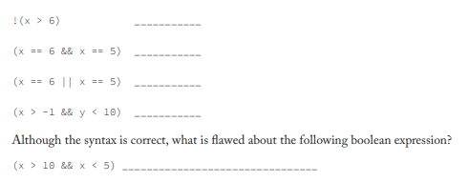

1. true
2. false
3. true
4. true
5. false
   1. It will always be false, because x can never be higher then 10 and below 5 at the same time.